



**CSU Sacramento**

**Department of Engineering**

**Lab 1 DC Measurements**

**Sam Lee**

**Partners: Jordan Moore, Jeffrey Hawthorn, Awfa Al-Rakabi**

**EEE 117L Network Analysis Laboratory**

**February 4th, 2019**

**Professor Sergio Aguilar Rudametkin**

**Section: 01**

**Day: Monday**

**Time: 5pm-7:40pm**

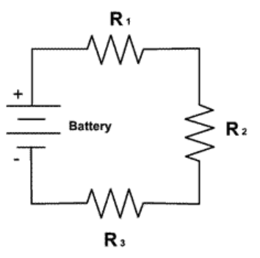

**Part 1: Introduction**

This lab utilizes several digital and analog instruments that can be used to measure resistance,

voltage, and current. These electronic instruments consist of the Digital Multi-meter and

oscilloscope. One of the instruments this lab requires is the Digital Multi-meter. A DMM is a

measuring instrument that can be used to measure all the parameters listed above. This lab

also requires the use of an oscilloscope which is an instrument that measures and displays

voltage signals as waveforms to a digital screen. The information gathered from both the DMM

and oscilloscope, allow the circuit built to be analyzed as circuit analysis is one of the main

focuses of this lab. The three circuits, required to be constructed by the lab assignment, deal with

voltage, resistance, and current calculations.

**Part 2: Purpose**

The purpose of this lab is to become familiar with circuit analysis tools, as well as the concepts and ideas of practical analysis. The specific tools we become familiar working with is the digital multimeter, in order to measure accurately the resistance, voltage, and current throughout a circuit. This lab came as two separate labs mashed into one super-packed with information. The first section of this lab teaches about specifically how to use a volt and current source, as well as the multimeter. Through using this equipment, we are gaining a knowledge in which we learn how to do analysis of actual results versus theoretical. While the second portion also teaches this, it also informs us how to use the concepts of Kirchhoff’s as well as current and voltage division.

A screenshot of a cell phone

Description generated with very high confidence

In Part 2A, we are tasked to measure the voltage from resistor 1, resistor 2, and the source on our circuit. Also, by using KVL and voltage division we can verify the resistor voltages by comparing them to are measured voltages. In Part 2B, we need to connect a x1 probe in parallel to Resistor 2 just like Figure 2. Then we measure the loaded voltages with a x1 probe setting. For Part 2 C we only change the probe setting from x1 to x10 therefore increasing the probes resistance. It was crucial for my team and I to use voltage division to find are actual loaded voltage values.



A screenshot of a cell phone

Description generated with very high confidence

In Part 3, we had to create the circuit shown in Figure 3 with the other three resistors. Then we are tasked to measure the current through all three resistors. It was crucial for my teammates and I to connect the ammeter in series within each circuit element we wanted to measure. Also, when calculating for each current we had to use the current division formula to find the current through resistor R4 and R5.



A screenshot of a cell phone

Description generated with very high confidence

**Part 3: Analysis and Discussion**

# The following table shows the resistance measurements for all resistors used and the resistance from the oscilloscope. It shows the specified value, measured value, and the percent error. The percent error shows us how off are measured values are from the specified values. Note that we measure the resistance of the oscilloscope while on and while off because there is a slight difference between them. Since the oscilloscope has two setting for the probes such as x1 and x10 there will be two measurements for each setting as well.

Percent Error Formula:

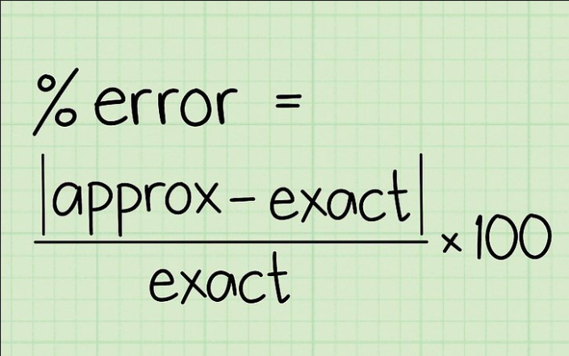

|  |  |  |  |
| --- | --- | --- | --- |
| Table 1: Resistance Measurements | | | |
| Part 1 Resistance Measurements | | | |
| Resistor | Theoretical Value | Actual Value (Measured) Value | Percent Error |
| R1 | 100 kΩ | 108.7 kΩ | 8.7% |
| R2 | 300 kΩ | 295.1 kΩ | 1.633% |
| R3 | 2 kΩ | 1.996 kΩ | .2% |
| R4 | 1 kΩ | .996 kΩ | .4% |
| R5 | 3 kΩ | 3.02 kΩ | .667% |
| Rx1 On | 1 MΩ | 1.0023 MΩ | .23% |
| Rx1 Off | 1 MΩ | 1.197 MΩ | 19.7% |
| Rx10 On | 10 MΩ | 9.992 MΩ | .08% |
| Rx10 Off | 10 MΩ | 10.19 MΩ | 1.9% |

The concept and application of voltage division was used on Figures 1 and 2 to verify the measured voltages with our multimeter. A 100 KΩ and a 300 KΩ resistor were used for R1 and R2 and were powered by a 2V source. Part 2A calculation is shown below.

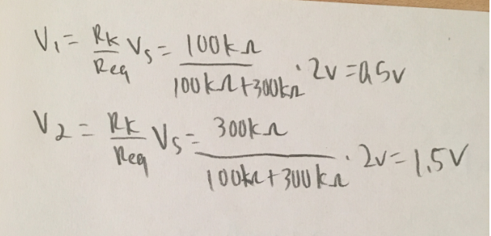

|  |  |  |  |
| --- | --- | --- | --- |
| Table 2: Voltage Divider | | | |
| Part 2: Voltage Measurements | | | |
| Unloaded Measurements |  |  |  |
| Circuit Element | Theoretical Value | Actual Value (Measured Value) | Percent Error |
| Vs1 | 2V | 2V | 0% |
| R1 | .5V | .534V | 6.8% |
| R2 | 1.5V | 1.450V | 3.33% |

# Voltage division was used on Figure 2. However, a probe was added to the circuit and acted as a third resistor. Therefore, the voltage readings on this circuit were now considered loaded with the introduction of the probe. The probes resistance was 1000 KΩ or 1 MΩ which was in parallel with R2 in the circuit. Therefore, this required us to add R2 and x1 probe resistance in parallel thus allowing us to find the voltage between R1, R2, and the probe by using voltage division.

The calculation for Part 2 B is as follows:

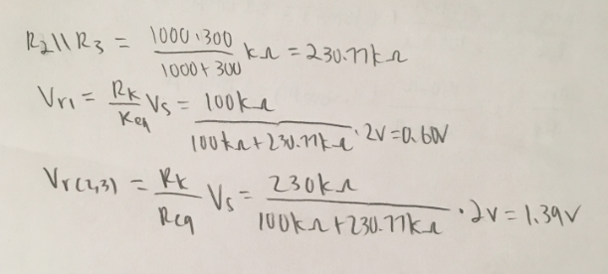

*Note: R3 is the probe with a x1 setting on it, therefore R3 has a resistance of 1 MΩ or 1000 KΩ.

|  |  |  |  |
| --- | --- | --- | --- |
| Table 3: Probe Connection Figure 2 x1 | | | |
| Loaded Measurements |  |  |  |
| Circuit Element | Theoretical Value | Actual Value (Measured Value) | Percent Error |
| Vs1 | 2V | 1.99V | .50% |
| R1 | .60V | .641V | 6.40% |
| R2 | 1.39V | 1.33V | 4.51% |

For this part we are still using Figure 2 but now the probe is set to x10 instead of x1 meaning the resistance was increased to 10 MΩ. Note that since R2 and the probe are in parallel the voltage is the same between them because that is a characteristic of resistors in parallel. Our data in this table seems to be accurate with minimal percent error. The calculations for Part 2C are as follows:

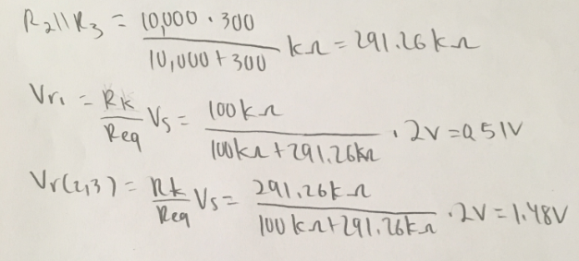

*Note: R3 is the probe with a x10 setting on it, therefore R3 has a resistance of 10 MΩ or 10,000 kΩ.

|  |  |  |  |
| --- | --- | --- | --- |
| Table 4: Probe Connection Figure 2 x10 | | | |
| Loaded Measurements |  |  |  |
| Circuit Element | Theoretical Value | Actual Value (Measured Value) | Percent Error |
| Vs1 | 2V | 1.999V | .50% |
| R1 | .51V | .546V | 6.59% |
| R2 | 1.48V | 1.439V | 2.85% |

For the third part, this table shows our current measurements for R3, R4, and R5. These measurements were by far the most accurate however the calculation for these were a bit more tedious and confusing as we had to use current division. As I previously have stated, Req on the current division formula involves resistors R4 and R5 and not the entire circuit because only R4 and R5 are in parallel. This was a bit confusing at first when I was initially trying to calculate for my current because I wasn’t using the formula properly. Also note that the voltage in this circuit is now 12V and involves the circuit in Figure 3. The calculation for Part 3 is as follows:

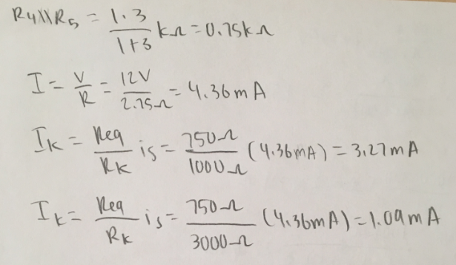

|  |  |  |  |
| --- | --- | --- | --- |
| Table 5: Current Divider | | | |
| Part 3: Current Measurements |  |  |  |
| Circuit Element | Theoretical Value | Actual Value (Measured Value) | Percent Error |
| R3 | 4.36mA | 4.3688mA | .20% |
| R4 | 3.27mA | 3.2731mA | .09% |
| R5 | 1.09mA | 1.0947mA | .43% |

# **Part 4: Conclusion**

The overall lessons that we learned from this lab consist of working with circuit analysis, building circuits, and working with Kirchhoff’s Current and Voltage Laws. In terms of circuit analysis, we had to analyze that the circuits were voltage and current dividers, respectively.

I found that building circuits was the most challenging portion of the lab because translating a schematic to a physical circuit was difficult. Another aspect of this lab that was very beneficial was learning how to use the laboratory equipment using the digital multimeter, ammeter, and the oscilloscope. Thorough hand calculations and measurements using the previously listed measurements helped us to perform a proper analysis of our data.

# **Part 5: Appendix**

KVL and KCL are used to prove voltage division and current division amongst resistors. These methods are used to solve for individual voltages and currents.

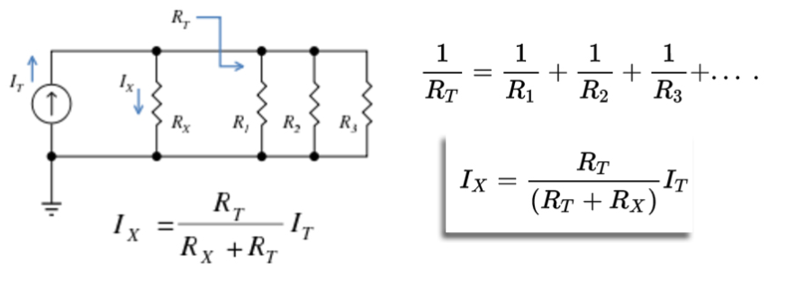

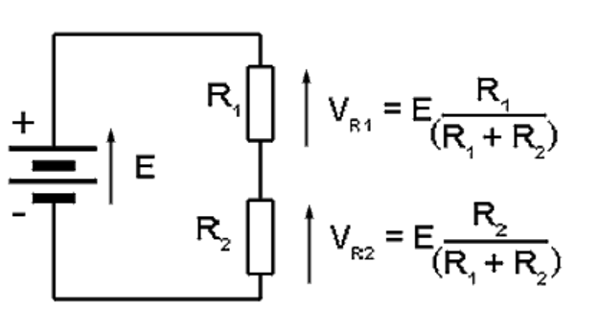

Kirchhoff’s Current Law states that the sum of all the currents going into one node is the same as the sum of the currents going out the node. While Kirchhoff’s Voltage Law states the sum of all the voltages in a loop are equal to zero. Ohm’s Law states that voltage is equal to the current times the resistance.

**Discussion Topics:**

1. During the lab we used Kirchhoff’s Voltage and Current Laws to calculate the voltage and current in the given current divider/voltage divider circuits. Kirchhoff’s current/voltage laws were verified in the case of lab because the measured values matched the calculated values.
2. Kirchhoff’s current and voltage laws were verified because our measured values matched the calculated values of the voltage and current that we found.
3. The oscilloscope probes met the advertised specifications because in the cases that we measured the voltage values in Part 2 we used the X1 and X10 probes. The X10 probe measurements were larger than the X1 measurements, this is due to the amplification of the measurement.
4. The expected voltage in the circuit is 2.00 volts and when we measured the input voltage, we obtained a value of 1.99 volts each time. So, the input voltage matched the source digital display.
5. The values of the resistors were close to the color code values of the resistors because the expected and calculated values are very close.
6. In order to disturb the circuit as little as possible, I would use the X1 probe because it does not amplify the circuit values as much as the X10 probe would.